Mathematical Methods Investigations

Year 12

Authors: Rom Cirillo
Margaret Denham
Jo Giumelli
James Heseltine

Editors: Rom Cirillo
Ann Shugg

For each topic three types of tasks are included:
- Extended investigation – an investigation which could be done in the student’s own time followed by an in-class validation. Solutions are provided where practicable for the preparation activity/investigation. For the in-class validation, there are solutions and marking keys which identify the mathematical behaviours that students may exhibit.
- In-class investigation – an investigation for which no prior preparation is required. Solutions and marking keys are provided.
- Investigative questions – a series of short questions which test the student’s ability to apply their learning, to justify their conclusions, to investigate and to generalise, or to solve problems. Such questions could be included in a response or examination assessment. Solutions and marking key are provided.

Screen shot have been produced using the CASIO ClassPad II emulator or the ti-nspire CAS emulator.

Most graphs and diagrams have been produced using efofex software.

© The investigations and solutions in this publication are for the sole use of staff and students of the purchasing school. It is a breach of copyright to distribute them in whole or part in any form now or in the future to any other school, company or person.

Contents:
MATHEMATICS METHODS: Year 12

3.1 Further differentiation and applications
Task 1: Extended investigation: The second derivative
Task 2: In-class investigation: Taylor series
Task 3: Investigative questions

3.2 Integrals
Task 4: Extended investigation: The area between a curve and the x-axis
Task 5: In-class investigation: TBA
Task 6: Investigative questions

3.3 Discrete random variables
Task7: Extended investigation: Distribution of sample means
Task 8: In-class investigation: Binomial distribution
Task 9: Investigative questions

4.1 The logarithmic function
Task10: Extended investigation: Logarithms
Task 11: In-class investigation: The logarithm function
Task 12: Investigative questions

4.2 Continuous random variables and the normal distribution
Task13: Extended investigation: The Normal distribution curve
Task 14: In-class investigation: Continuous distribution curves
Task 15: Investigative questions

4.3 Interval estimates for proportions
Task16: Extended investigation: TBA
Task 17: In-class investigation: TBA
Task 18: Investigative questions

This package only contains the investigations associated with topic 3.1: Further differentiation and applications

If your school has purchased the complete set of 18 investigations, you will be informed when the rest are ready for delivery/download, which will be sometime later in Term 1.

TASK 1

The Second Derivative

Extended Investigation

Unit 3

Topic 3.1: Further Differentiation and Applications

Course-related information

The concepts and skills included in this investigation relate to the following dot points within the WA Mathematics Methods syllabus:

3.1.11 apply the concept of the second derivative as the rate of change of the first derivative function

3.1.13 examine the concepts of concavity and points of inflection and their relationship with the second derivative

3.1.15 sketch the graph of a function using first and second derivatives to locate stationary points and points of inflection

Background information

This task investigates the connection between the second derivative and the concavity of a function. Students should be able to differentiate polynomials and be familiar with finding stationary points using the first derivative and testing their nature using the “sign test”.
Students will not be asked to differentiate exponential or trigonometric functions.

Task conditions.

A preparation activity is provided for students to work through before attempting the in-class validation. They should be provided with the opportunity to check their working and conclusions from this preparation activity. Students should not be permitted access to their preparation material during the validation, which should take 40 – 50 minutes to complete.
Use of a graphical/CAS calculator is assumed.

The Second Derivative

Extended investigation Part 1: Preparation activity

You will be familiar with the role of the first derivative in identifying the stationary points of a function. In this task, you will investigate the role of the second derivative in identifying features of the graph of a function.
A: Introductory Exercises
- Determine whether the following sequences are increasing or decreasing.
  - -2, -1, 0, 1, 2
  - -0.3, -1.5, -2.8, -3, -3.2, -5.9
- For each of the following sequences, underline the increasing values in red and the decreasing values in blue.
  - 12, 15, 18, 22, 21, 20, 19, 21, 25, 29
  - -5, -7, -11, -10, -8, -4, -5, -6, -9
B: Connecting features of graphs to their derivatives
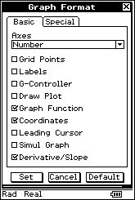
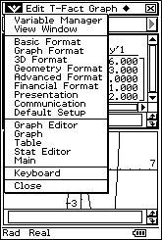
Before you start:
Set up your CAS calculator to show the derivative of points on a graph. To do this on a ClassPad, check the ‘Derivative/Slope’ function in the ‘Graph Format’ settings

- Graph $y=x^{3}-3x^{2}-3x+1$ on your CAS calculator.
Copy the graph onto graph paper, indicating the coordinates of all intercepts, turning points and points of inflection. Commands for determining these points can be found in the ‘Analysis’ Menu of the ClassPad.
- Using the ‘Trace’ command on your calculator, determine the values of x for which the gradient of y is:
(a) increasing. (b) decreasing.
Indicate your findings on the graph you have drawn, by highlighting sections of the curve where the gradient is increasing in one colour and decreasing in another colour.
Comment on the concavity of the function in the highlighted sections.

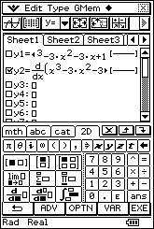
- Graph $\frac{dy}{dx},$ the gradient function, on your CAS calculator. One way of graphing the gradient function on a ClassPad is shown here.
Determine the values of x for which the gradient function is

(a) increasing.
(b) decreasing.

Confirm that these values match your findings in Question 2.

- Graph $\frac{d^{2}y}{dx^{2}}$ , the gradient of the gradient function, on your CAS calculator.
Determine the value(s) of x for which $\frac{d^{2}y}{dx^{2}}$is

(a) positive.
(b) negative.
(c) zero.

Relate these values of x to features of your graph of the function, $y=x^{3}-3x^{2}-3x+1$.

C: Further investigation
Apply the process outlined in Part B to each of the following functions.

- $y=x^{4}+2x^{3}-2x$

- $y=x^{4}$

D: Conclusion
Complete the following to make them true statements.

- When the gradient of a function is increasing, the function is concave ____________ and the second derivative of the function is ________________.
- When the gradient of a function is decreasing, the function is concave ____________ and the second derivative of the function is ________________.
- When the concavity of a function changes at a point of inflection, the second derivative of the function is _____________.

End of questions
The Second Derivative

Extended investigation Part 2: In-class validation
Total marks: 38

Question 1 (10 marks)

Consider the function $y=x^{4}-4x^{2}$

- Graph the function on the axes provided (5)
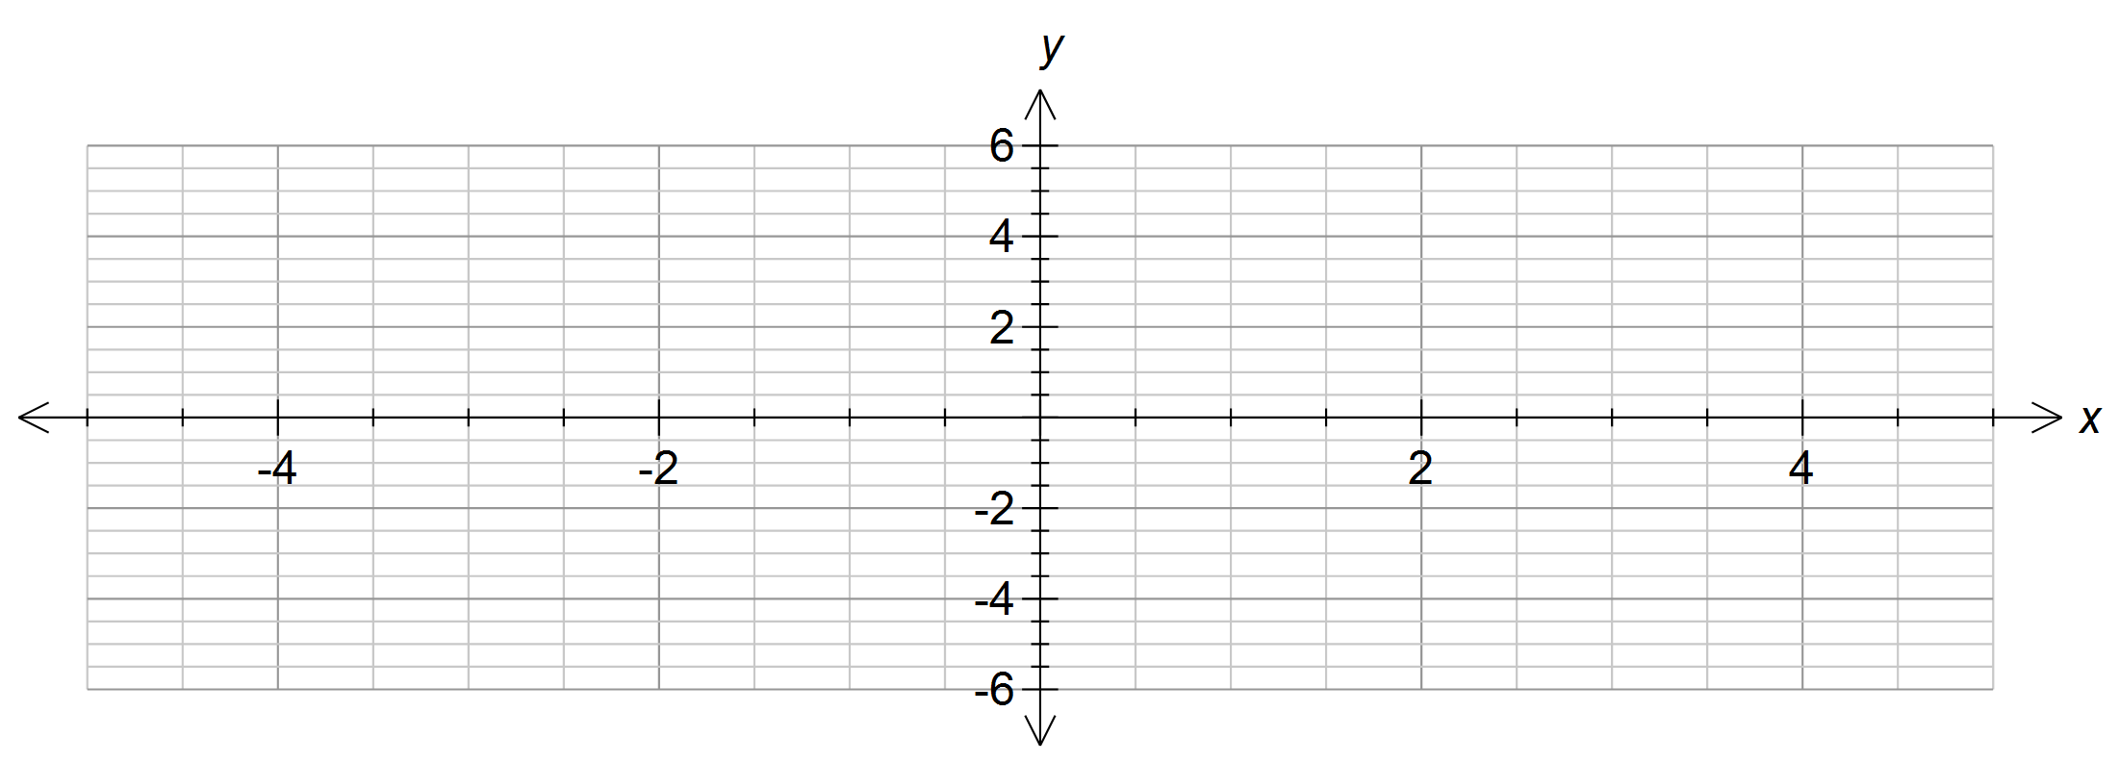

- State the values of $x$ for which the gradient of the function is (2)

(i) increasing.

(ii) decreasing.

- State the value(s) of x for which the second derivative of the function is (3)

(i) negative.

(ii) zero.

(iii) positive.

Question 2 (12 marks)

The relationship between the concavity of a function and the sign of the second derivative of that function is a useful tool for testing whether a stationary point is a maximum or minimum, and provides an alternative method to the “first derivative sign test”.

- Use calculus techniques to show that the stationary points of $f\left(x\right)= \frac{x^{3}}{6}+2x^{2}-1$ occur at $x=- 8$ and $x=0$. (3)

- Determine the second derivative, $f’’\left(x\right).$ (1)

- Determine $f’’(- 8)$ and $f’’\left(0\right).$ (2)

- Explain how your answers to (c) can be used to identify whether the stationary points are maxima or minima. (4)

- Hence, state the nature of the stationary points at $x=- 8$ and $x=0$. (2)

Question 3 (9 marks)

Josh is investigating the first and second derivatives of some functions.

(a) For the function$, y=f(x)$, at the point where $x=a,$ Josh’s calculations show that $f'\left(a\right)=0$ and $f''(a)=5$. What feature of the graph occurs at $x=a$? (2)

(b) For the function, $y=g(x)$, Josh discovers that the second derivative is positive for
all $x$. (2)
(i) What does this indicate about the function, $y=g(x)$?

(ii) Suggest a possible function for $g(x)$.

(c)` For the polynomial function, $y=x^{n},$ Josh finds that at the point where $x=0$, both the first and second derivatives are zero. (5)
(i) List the possible features of the graph that might be present at $x=0$.

(ii) State the appropriate value(s) of n for each feature listed above.

Question 4 (5 marks)

Below is the graph of $f''\left(x\right)$, the second derivative of function, $f\left(x\right).$
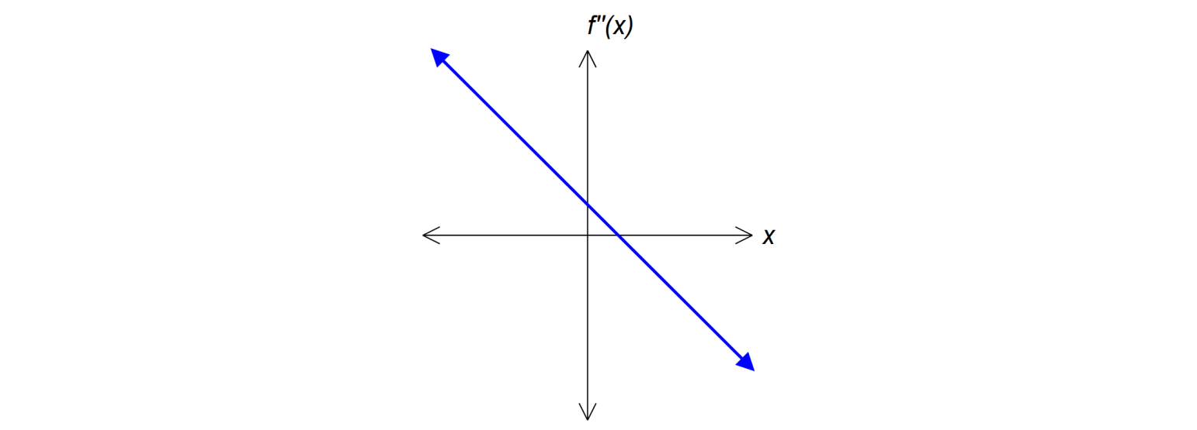

(a) Sketch the graph of a possible $f^{'}\left(x\right),$ the first derivative of function,$f\left(x\right).$ (2)
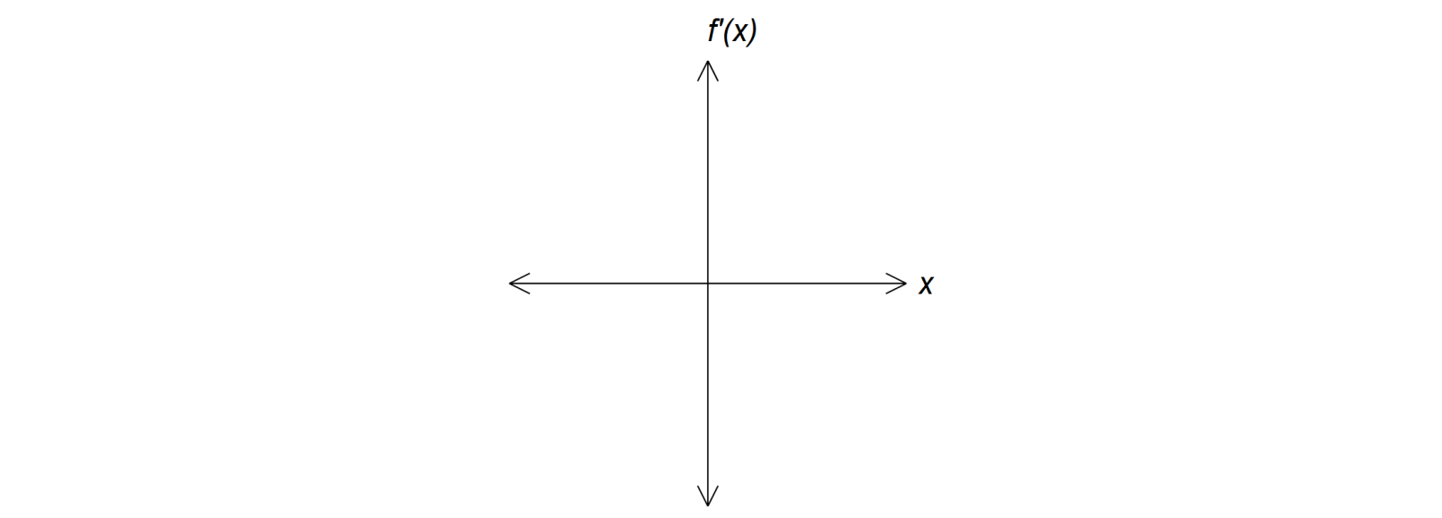

(b) Sketch the graph of a possible function for $f\left(x\right).$ (3)
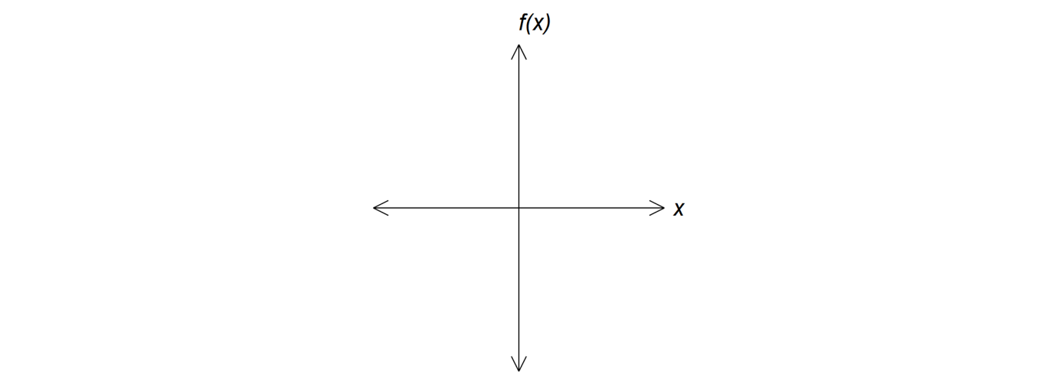

End of questions

The Second Derivative

Extended investigation Part 1: Preparation activity
Solutions

A: Introductory Exercise
- (a) increasing (b) decreasing

2. (a) 12, 15, 18, 22, 21, 20, 19, 21, 25, 29
(b) -5, -7, -11, -10, -8, -4, -5, -6, -9

B: Connecting features of graphs to their derivatives
- $y=x^{3}-3x^{2}-3x+1$
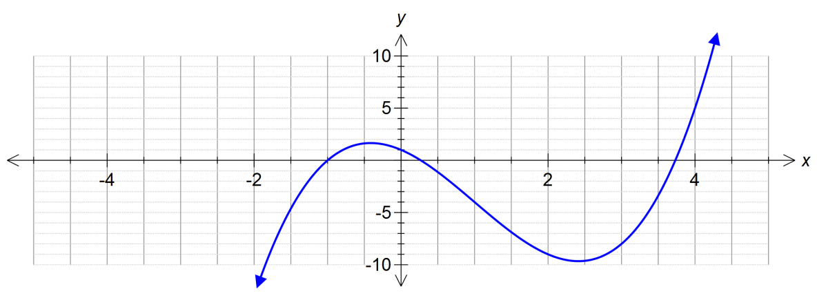x-intercepts at (-1,0), (0.27, 0) and (3.73, 0)
y-intercept at (0,1)
maximum at ( -0.41, 1.66)
minimum at (2.41, -9.66)
point of inflection at (1, -4)
- (a) increasing when $x>1$
(b) decreasing when $x<1$
concave down when $x<1$, concave up when $x>1$
- (a) increasing when $x>1$
(b) decreasing when $x<1$
[ the gradient function is quadratic with a minimum turning point at $x$ = 1 ]

- (a) positive when $x>1$
(b) negative when $x<1$
(c) zero when $x$ = 1
Second derivative is positive when the gradient function is increasing and the function is concave up.
Second derivative is negative when the gradient function is decreasing and the function is concave down.
Second derivative is zero at the point of inflection.

C: Further Investigation
C 1.1 $y=x^{4}+2x^{3 }-2x$
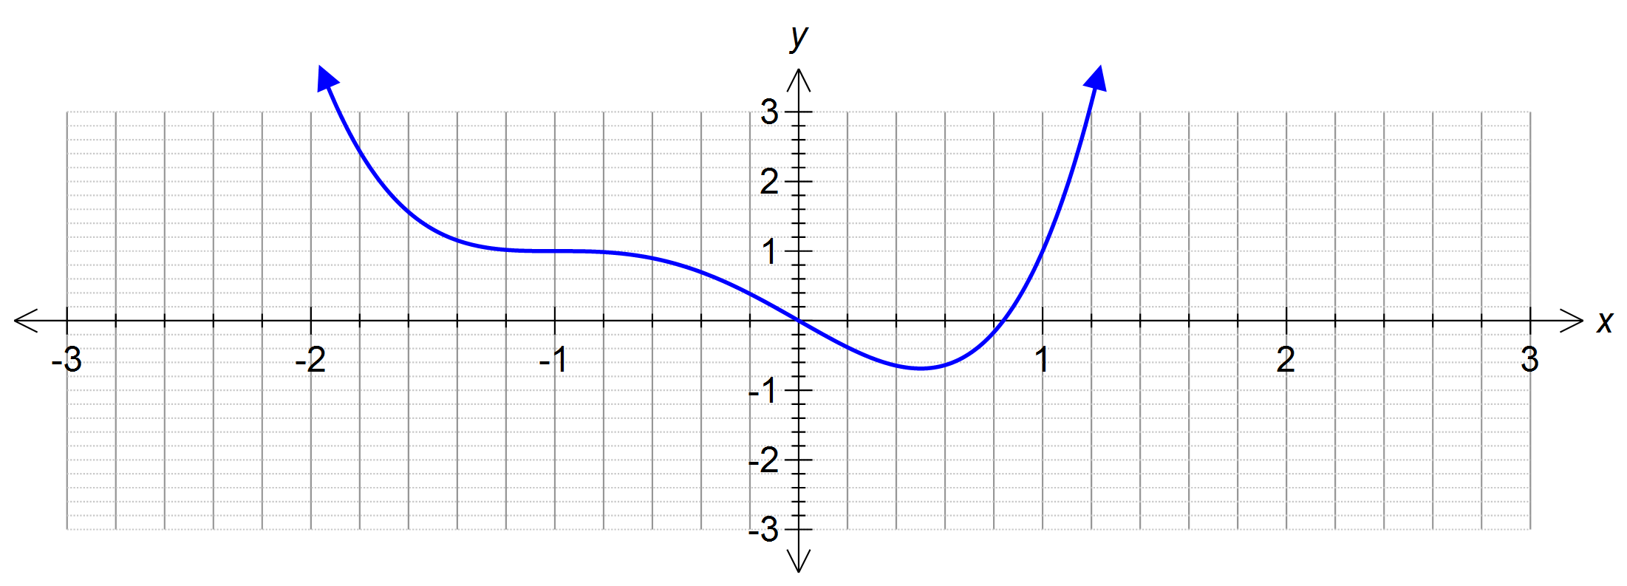 x-intercepts at (0,0) and (0.84,0)
y-intercept at (0,0)
minimum at (0.5, -0.69)
points of inflection at (-1, 1) and (0,0)
1.2 (a) increasing when $x<-1$ and when $x>0$
(b) decreasing when $-1<x<0$
concave up when $x<-1$ and when $x>0$,
concave down when$-1<x<0$

1.3 (a) increasing when $x<-1$ and when $x>0$
(b) decreasing when $-1<x<0$
[ the gradient function is cubic with a maximum at $x$ = – 1 and a minimum at$x$ = 0 ]
1.4.. (a) positive when $x<-1$ and when $x>0$
(b) negative when $-1<x<0$
(c). zero when $x$ = – 1 and when $x$ = 0
Second derivative is positive when the gradient function is increasing and the function is concave up.
Second derivative is negative when the gradient function is decreasing and the function is concave down.
Second derivative is zero at the points of inflection.

C 2.1 $y=x^{4}$
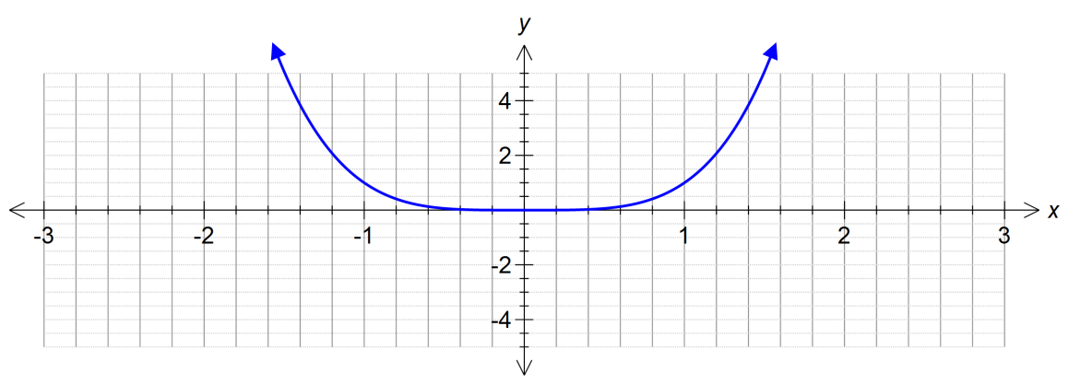
x-intercept at (0,0)
y-intercept at (0,0)
minimum at (0,0)
No points of inflection

2.2 (a) increasing for all $x$
(b) never decreasing
concave up for all $x$
2.3 (a) increasing for all $x$
(b) never decreasing
[ the gradient function is cubic and has a point of horizontal inflection at $x$ = 0 ]

2.4 (a) positive for all $x$ except $x$ = 0
(b) never negative
(c) zero when $x$ = 0
Second derivative is positive when the gradient function is increasing and the function is concave up.
Second derivative is zero at $x$ = 0 but since there is no change in the concavity of the function, (0,0) is not a point of inflection.

D: Conclusion
- When the gradient of a function is increasing, the function is concave up and the second derivative of the function is positive.
- When the gradient of a function is decreasing, the function is concave down and the second derivative of the function is negative.
- When the concavity of the function changes at a point of inflection, the second derivative of the function is zero.

End of questions

The Second Derivative

Extended investigation Part 2: In-class Validation
Solutions and marking key

Question 1(a)
Solution
$$y=x^{4}-4x^{2}$$
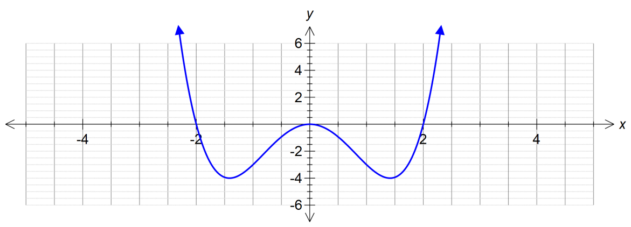
Mathematical behaviours | Marks
- Shape of graph.  - Correct intercepts on axes. (-2,0), (0,0), (2,0)  - (approx) location of turning points. min: ( -1.4, -4), (1.4, -4) max: (0,0)  - (approx) location of points of inflection. (-0.82, -2.24), (0.82, -2.24) | 1  1  2  1

Question 1(b) – (c)

 | Solution | Mathematical behaviours | Marks
(b) | (i) $x<-0.82$, $x>0.82$  (ii) $-0.82<x<0.82$ | - Correct intervals  - Correct interval | 1  1
(c) | (i) $-0.82<x<0.82$  (ii) $x=-0.82, 0.82$  (iii) $x<-0.82$, $x>0.82$ | - Correct interval  - Correct values for x  - Correct intervals | 1  1  1

Question 2(a)
Solution
- $f’\left(x\right)=\frac{x^{2}}{2}+4x$
Stationary point at $f’(x)=0$
i.e. $\frac{x^{2}}{2}+4x=0$
$$x\left(\frac{x}{2}+4\right)=0$$
$$x=0, \frac{x}{2}+4=0$$
$$x=-8$$
Therefore stationary points at $x=0$ and $x=- 8$
Mathematical behaviours | Marks
- Differentiation correct  - $f^{'}\left(x\right)=0$  - Solves and states solution | 1  1  1

Question 2(b)-(e)
 | Solution | Mathematical behaviours | Marks
(b) | $$f’’(x)=x+4$$ | - Differentiation correct | 1
(c) | $$f’’\left(- 8\right)=- 4, f’’(0)=4$$ | - Correct values | 2
(d) | $f’’\left(- 8\right)<0 ,$therefore the graph is concave down at $x=- 8$  $f’’\left(0\right)>0$, therefore the graph is concave up at $x=0$ | - Connection between sign of second derivative and concavity at $x=- 8$  - Connection between sign of second derivative and concavity at $x=0$ | 2  2
(e) | maximum turning point at $x=- 8$  minimum turning point at$x = 0$ | - Correct identification of nature of each stationary point | 1  1

Question 3(a)
Solution
Minimum turning point
Mathematical behaviours | Marks
- Identifies as a turning point  - States turning point is a minimum | 1  1

Question 3(b)

Solution
(i) $g(x)$ is concave up for all x.
(ii) Examples of functions with this property: $g\left(x\right)=x^{2} or g\left(x\right)=2^{x}$
Mathematical behaviours | Marks
- (i) Connects second derivative to correct concavity  - (ii) Correctly identifies a function that is concave up for all x | 1  1

Question 3(c)

Solution
(i) Point of horizontal inflection or minimum turning point
(ii) Point of horizontal inflection when n = 3, 5, 7, 9…
Minimum turning point when n = 4, 6, 8, 10…
Mathematical behaviours | Marks
- (i) Identifies both possibilities  - (ii) Determines at least one correct value of n for each type of point  - (ii) Determines the set of n for each type of point | 2  2  1

Question 4
Question 4(a) Question 4(b)
Solution |  | Solution
Example of possible gradient function  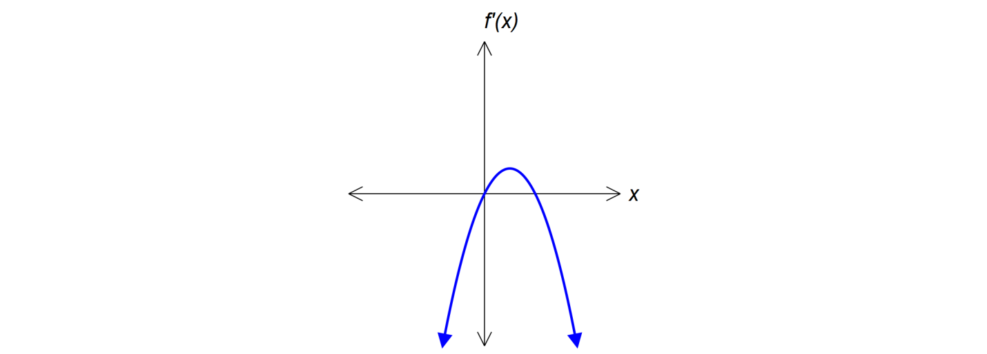 |  | Example of possible function  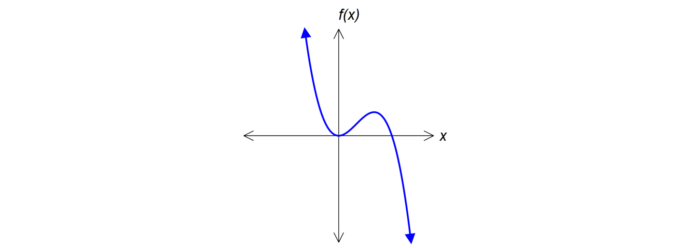
Mathematical behaviours | Marks | Mathematical behaviours | Marks
- $f^{'}\left(x\right)$ is quadratic and concave down  - maximum turning point of $f^{'}\left(x\right)$ aligns with the root of $f^{''}\left(x\right)$ | 1  1 | - $f\left(x\right)$ is cubic  - turning points of $f\left(x\right)$ align with the roots of $f'\left(x\right)$  - point of inflection of $f\left(x\right)$ aligns with the root of $f''\left(x\right)$  and the turning point of $f'\left(x\right)$ | 1  1  1

TASK 2

TAYLOR SERIES

In-Class Investigation

Unit 3

Topic 3.1: Further Differentiation and Applications

Course-related information

The concepts and skills included in this investigation relate to the following dot points within the WA Mathematics Methods syllabus:

3.1.5 establish the formulas $\frac{d}{dx}$(sin 𝑥) = cos 𝑥 and $\frac{d}{dx}$ (cos 𝑥) = − sin 𝑥 by numerical estimations of the limits and informal proofs based on geometric constructions
3.1.3 establish and use the formula $\frac{d}{dx}\left( e^{x}\right)=e^{x}$

Background information

Students should have reviewed their knowledge of trigonometric functions and the differentiation of polynomial and exponential functions before sitting this assessment but they should not have learnt how to differentiate trigonometric functions. They should also be familiar with factorial notation. This investigation provides students with an opportunity to discover the formulas relating to trigonometric differentiation through the investigation of Taylor series.

Task conditions

This task consists of an in-class investigation for which students may need 45 – 55 minutes to complete. Students do need to be familiar with tabulation and graphing using technology and it is expected that they will have access to such technology during the investigation.

Taylor Series

In-class investigation Total marks: 48

A Taylor series uses the sum of an infinite number of polynomial terms to represent a non- polynomial function. Even though such a sum cannot be calculated, an approximation of the function can be obtained by using a finite number of terms. The more terms used, the better the approximation.

To complete this task, you will need to have an understanding of

- polynomial differentiation: if $f(x)=ax^{n}, then f'(x)=n.{ax}^{n-1}$ and

- factorial notation: $n!=n×\left(n-1\right)×\left(n-2\right)× … ×2×1$

Question 1 (21 marks)

Consider the Taylor series
$$f\left(x\right)=x-\frac{x^{3}}{3!}+\frac{x^{5}}{5!}-\frac{x^{7}}{7!}+…$$

- The Taylor polynomial formed by the first 4 terms of $f(x)$ is
$$f\left(x_{4}\right)=x-\frac{x^{3}}{3!}+\frac{x^{5}}{5!}-\frac{x^{7}}{7!}$$

Graph $f(x_{4})$ on the axes below. Write the coordinates of any intercepts and turning points onto your graph. (6)

x
-
5
5
f(x)
-
3
-
2
-
1
1
2
3
- Continue the series for another 3 terms and hence write $f\left(x_{7}\right)$. (3)

- Graph $f\left(x_{7}\right)$ on the axes below. Write the coordinates of any intercept and turning points onto your graph. (6)
x
-
5
5
f(x)
-
3
-
2
-
1
1
2
3

- Suggest the function represented by the Taylor series, $f\left(x\right).$ (2)

- Suggest values of x for which $f\left(x\right)$ provides a good approximation of the function when

  - four terms of the series are used. (2)

  - seven terms of the series are used. (2)

Question 2 (13 marks)
Consider the Taylor series
$g\left(x\right)=1-\frac{x^{2}}{2!}+\frac{x^{4}}{4!}-\frac{x^{6}}{6!}+…$

- Continue the series for another 3 terms and hence write $g\left(x_{7}\right)$. (3)

- Graph $g\left(x_{7}\right)$on the axes below. Write the coordinates of any intercept and turning points onto your graph. (6)
x
-
5
5
g(x)
-
3
-
2
-
1
1
2
3

- Suggest the function represented by the Taylor series, $g\left(x\right).$ (2)

- Suggest values of x for which $g\left(x\right)$ provides a good approximation of the function when seven terms of the series are used. (2)

Question 3 (10 marks)

Recall the Taylor series from Questions 1 and 2

$f\left(x\right)=x-\frac{x^{3}}{3!}+\frac{x^{5}}{5!}-\frac{x^{7}}{7!}+…$ and $g\left(x\right)=1-\frac{x^{2}}{2!}+\frac{x^{4}}{4!}-\frac{x^{6}}{6!}+…$

- Show that $f'(x)=g(x)$. (4)

- Determine $g'\left(x\right)$ and comment on the result. (4)

- State the relationships from (a) and (b) above in terms of the functions you suggested for $f\left(x\right)$ and $g\left(x\right)$ in Questions 1(d) and 2(c). (2)

Question 4 (4 marks)

Another Taylor series is defined by
$h\left(x\right)=1+x+\frac{x^{2}}{2!}+\frac{x^{3}}{3!}+\frac{x^{4}}{4!}+…$

- Determine $h'\left(x\right)$. (2)

- Suggest the function for which $h\left(x\right)$ is a good approximation. (2)

End of questions

Taylor Series
In-class investigation
Solutions and marking key

Question 1(a)
Solution
$f\left(x_{4}\right)$
x
-
5
5
f(x)
-
3
-
2
-
1
1
2
3
Roots at (-3.08, 0), (0,0) and (3.08, 0)
Minimum at (-1.57, -1) Maximum at (1.57, 1)

Mathematical behaviours | Marks
- Correct intercepts and turning points  - Correct shape of graph | 5  1

Question 1(b)
Solution
$$f\left(x_{7}\right)=x-\frac{x^{3}}{3!}+\frac{x^{5}}{5!}-\frac{x^{7}}{7!}+\frac{x^{9}}{9!}+\frac{x^{11}}{11!}-\frac{x^{13}}{13!}$$

Mathematical behaviours | Marks
- Correct +/- signs for each term  - Correct power of $x$ for each term  - Correct factorial for each term | 1  1  1

Question 1(c)
Solution
$f\left(x_{7}\right)$
x
-
5
5
f(x)
-
3
-
2
-
1
1
2
3
Roots at (-5.98,0), (-3.14,0), (0,0), (3.14,0) and (5.98,0)
Maxima at (-4.69,1) and (1.57,1) Minima at (-1.57,-1) and (4.69,-1)

Mathematical behaviours | Marks
- Correct intercepts and turning points  - Correct shape of the graph | 5  1

Question 1(d) – (e)
 | Solution | Mathematical behaviours | Marks
(d) | $$f\left(x\right)=sin⁡x$$ | - Correct function | 2
(e) | (i$) -π≤x≤π$  or $-3≤x≤3$  (ii) $-2π≤x≤2π$  or $-6≤x≤6$ | - Correct upper and lower boundaries  - Correct upper and lower boundaries |  | 2  2

Question 2(a)
Solution
$g\left(x_{7}\right)=1-\frac{x^{2}}{2!}+\frac{x^{4}}{4!}-\frac{x^{6}}{6!}+\frac{x^{8}}{8!}+\frac{x^{10}}{10!}-\frac{x^{12}}{12!}$

Mathematical behaviours | Marks
- Correct +/- signs for each term  - Correct power of $x$ for each term  - Correct factorial for each term | 1  1  1

Question 2(b)
Solution
$g\left(x_{7}\right)$
x
-
5
5
g(x)
-
3
-
2
-
1
1
2
3
Roots at (-4.69,0), (-1.57,0), (1.57,0) and (4.69,0)
Maximum at (0,1) Minima at (-3.14,-1) and (3.14,-1)
Mathematical behaviours | Marks
- Correct intercepts and turning points  - Correct shape of the graph | 5  1

Question 2(c) – (d)
 | Solution | Mathematical behaviours | Marks
(c) | $$g\left(x\right)=cos⁡x$$ | - Correct function | 2
(d) | $$-5≤x≤5$$ | - Correct upper and lower boundaries  - Not $-2π<x<2π$ since  $g(2π)= g\left(-2π\right)=2.465$ is  not a good approximation for  $cos⁡(2π)= \cos\left(-2π\right)=1$ | 2
Question 3(a)
Solution
$f^{'}\left(x\right)=1-\frac{{3x}^{2}}{3!}+ \frac{5x^{4}}{5!}- \frac{7x^{6}}{7!}+…$
$=1- \frac{x^{2}}{2!} + \frac{x^{4}}{4!} - \frac{x^{6}}{6!} +…=g(x)$

Mathematical behaviours | Marks
- Differentiates correctly  - Simplifies fractions involving factorial correctly  - States the relationship | 2  1  1

Question 3(b)
Solution
$$g^{'}\left(x\right)=0-\frac{2x}{2!}+\frac{4x^{3}}{4!}-\frac{6x^{5}}{6!}+…$$
$= - x + \frac{x^{3}}{3!} – \frac{ x^{5}}{5!}+…$ $= - f(x)$

Mathematical behaviours | Marks
- Differentiates correctly  - Simplifies fractions involving factorial correctly  - States the relationship | 2  1  1

Question 3(c)
Solution
$\frac{d}{dx}(sin x)=cos⁡x$ and $\frac{d}{dx}\left(cos x\right)=- sin⁡x$

Mathematical behaviours | Marks
- Correct relationships | 2

Question 4(a)
Solution
$${ h}^{'}\left(x\right)=0+1 +\frac{2x}{2!}+\frac{3x^{2}}{3!}+\frac{{4x}^{3}}{4!}+…$$
$= 1 +x + \frac{x^{2}}{2!} + \frac{x^{3}}{3!} +$ ... = $h(x)$

Mathematical behaviours | Marks
- Differentiates correctly  - Simplifies fractions involving factorial correctly | 1  1

Question 4(b)
Solution
$h^{'}\left(x\right)=h(x)$ which suggests $h\left(x\right)= e^{x}$

Mathematical behaviours | Marks
- Identifies $h^{'}\left(x\right)=h(x)$  - Correct function | 1  1

TASK 3

Investigative questions

Unit 3

Topic 3.1: Further Differentiation and Applications

Course-related information

The concepts and skills included in these investigative questions relate to the following dot points within the WA Mathematics Methods syllabus:

3.1.1 estimate the limit of $\frac{a^{h}-1 }{h}$ as ℎ→0 using technology, for various values of 𝑎 >0

3.1.2 identify that 𝑒 is the unique number 𝑎 for which the above limit is 1

3.1.3 establish and use the formula $\frac{d}{dx}\left(e^{x}\right)=e^{x}$

3.1.4 use exponential functions of the form $Ae^{kx}$ and their derivatives to solve practical problems.

3.1.6 use trigonometric functions and their derivatives to solve practical problems.

3.1.9 apply the product, quotient and chain rule to differentiate functions such as 𝑥𝑒^{𝑥},
tan𝑥, $\frac{1}{x^{n}}$, 𝑥sin𝑥, 𝑒^{−𝑥}sin𝑥 and 𝑓(𝑎𝑥-𝑏).

3.1.13 examine the concepts of concavity and points of inflection and their relationship with the second derivative

Background information

Each of the questions provided can stand alone and may be incorporated into different tasks. It is not intended that they form part of the same assessment.
The ability of students to choose and use appropriate technology to enhance and extend the development of a concept is also required for some of the questions.

Task conditions
Each question should be undertaken under test conditions and should be completed within 15 minutes. Use of a graphical/CAS calculator is assumed.

Question 1 (15 marks)

A catenary is a curve that describes the shape of a chain or cord hanging freely between two points of support. Suspension bridges, cables and arches may follow a catenary.

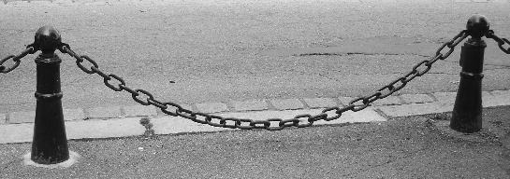

A catenary is similar in appearance to a parabola. In this question, you will approximate a simple catenary with a parabola and compare them.

- Graph the catenary $y=e^{ \frac{x}{2}}+e^{- \frac{x}{ 2}}$ on your CAS calculator and then, using a pencil, draw the graph on the axes below. (3)
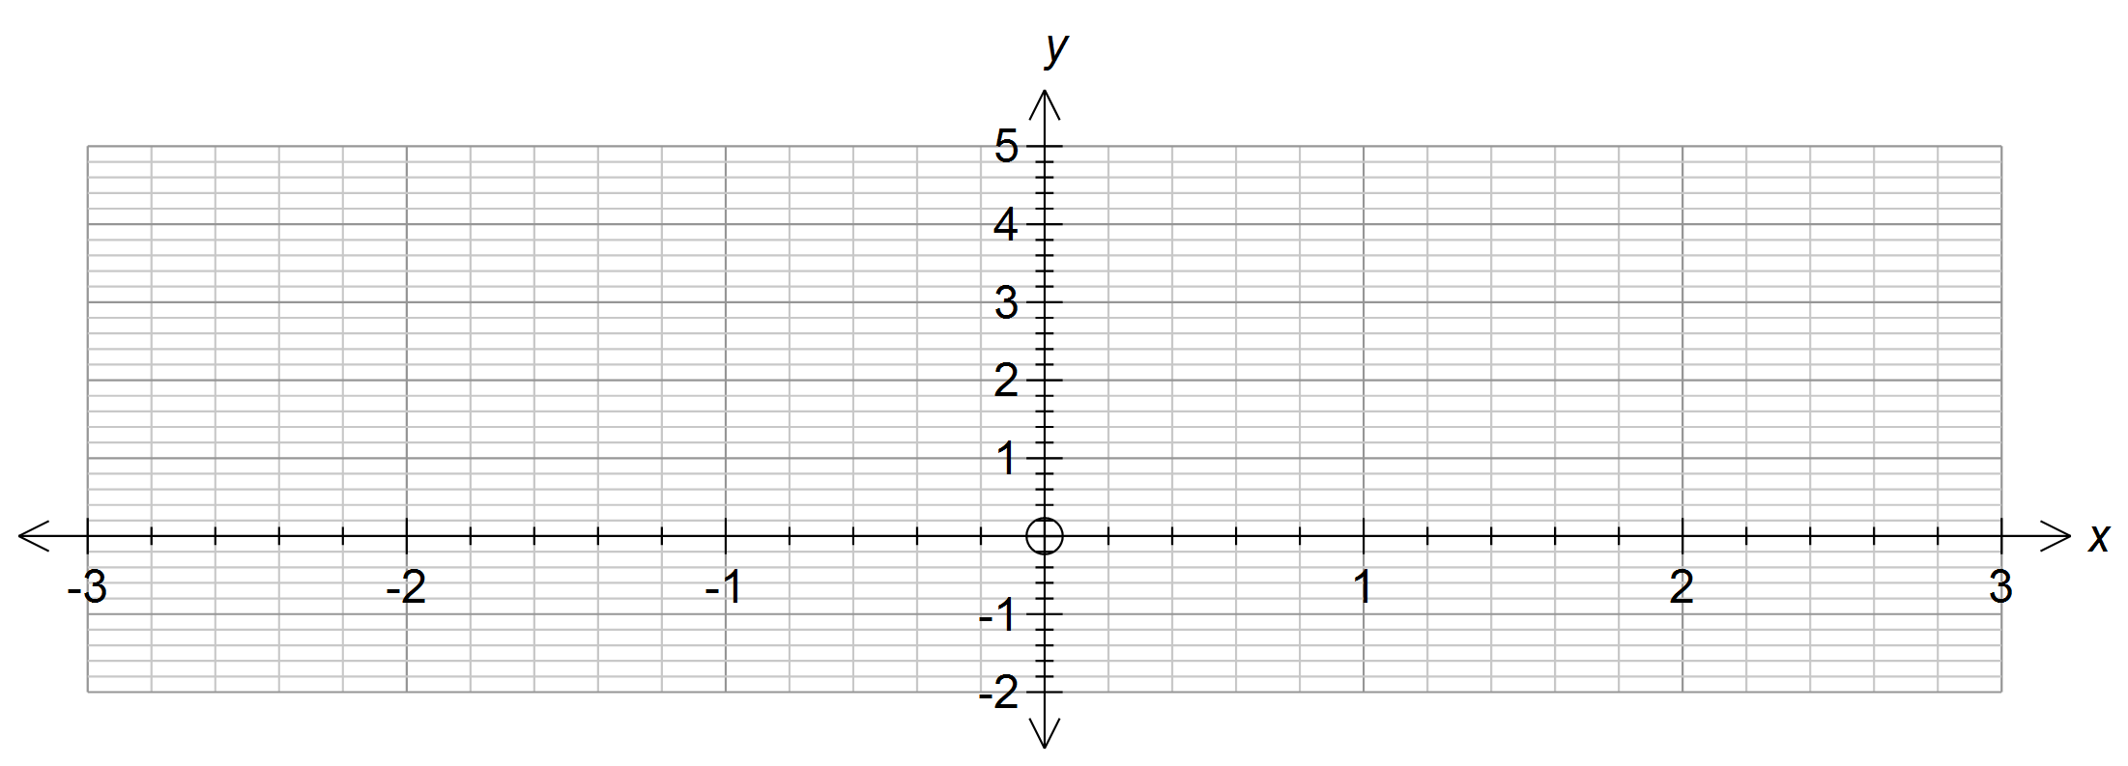

- Experiment with quadratic functions of the form $y=ax^{2}+b$, where a and b are constants with one decimal place, until you find a function that closely approximates the catenary on the given domain. Write the equation of this quadratic function in the space below. (2)

- Using a biro, draw the graph of this quadratic function on the axes above.
Label both graphs clearly and circle their points of intersection. (3)
- State, correct to 3 decimal places where necessary, the coordinates of the points of intersection of the two curves. (2)

Consider the sections of the curves between these points of intersection.

- Write an equation for D in terms of x where D represents the distance between the parabola and the catenary. (2)

D =

- Derive an expression for and use it to determine the value(s) of x for which the distance between the two curves is a maximum. (3)

Question 2 (8 marks)

A piston in an engine travels up and down causing a flywheel to rotate. Each time the piston travels from the bottom of the cylinder to the top and back again, the flywheel completes
1 revolution.
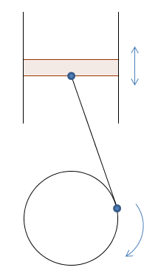

When the flywheel is turning at its maximum speed of 3000 revolutions per minute,
the position, $x$ (millimetres), of the piston at any time, $t ($seconds), is given by

$$x=75cos⁡(315t)$$

- Determine an equation for the velocity,$v$, of the piston at any time, t. (2)

- What is the maximum velocity of the piston? Give your answer in metres per second.
(2)

The velocity of the piston is limited by the strength of the material used to make it. The piston manufacturer has decided to trial a new alloy which will allow the maximum velocity of the piston to increase to 30 metres per second.

(c) With the piston made of this new alloy, determine the formula for
the position, $x,$ of the piston at any time, t. (2)

(d) Determine the resulting maximum velocity (in revolutions per minute)
of the flywheel. (2)

Question 3 (6 marks)
On each set of axes, sketch a suitable graph for the function, $y=f\left(x\right),$ with the properties given.

- $a>b>0$ (4)
$$f(a)=f(b)=0$$
$$f’(a)=0, f’’(a)>0$$
$$f’(b)>0$$
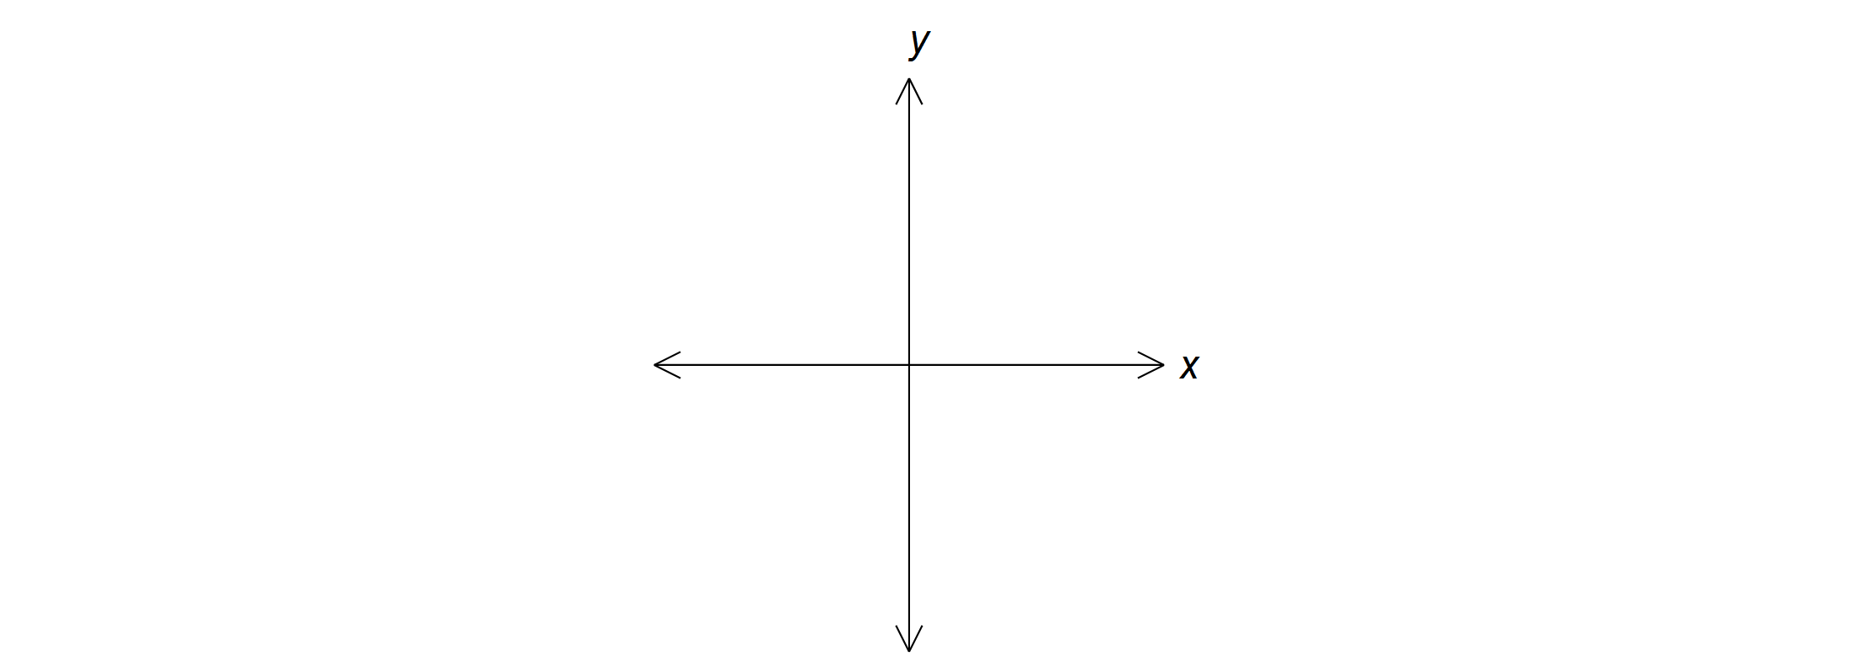

- $f’(x) >0$ for all $x$ (2)
$f’’(x)<0$ for all $x$

Question 4 (4 marks)

- Evaluate, correct to 5 decimal places. (3)

(i) | $$2+\frac{1}{1+\frac{1}{2}}$$
(ii) | $$2+\frac{1}{1+\frac{1}{2+\frac{2}{3}}}$$
(iii) | $$2+\frac{1}{1+\frac{1}{2+\frac{2}{3+\frac{3}{4}}}}$$

- Determine the limiting value of the continued fraction. (1)

$$2+\frac{1}{1+\frac{1}{2+\frac{2}{3+\frac{3}{4+…}}}}$$

End of questions

Investigative Questions
Solutions and marking key

Question 1(a)
 | Solution
 | 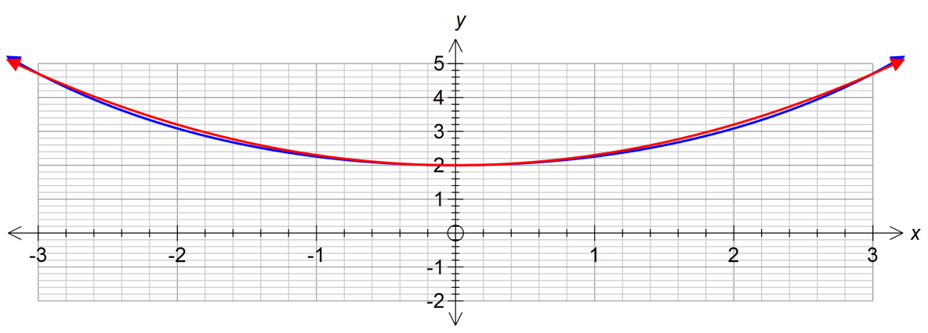
Mathematical behaviours |  | Marks
- Correct shape  - Correct y intercept  - Accuracy of plotted points |  | 1  1  1

Question 1 (b) – (e)
 | Solution | Mathematical behaviours | Marks
(b) | $$y=0.3x^{2}+2$$ | - Correct a value to 1 dp  - Correct b value | 1  1
(c) | See red curve in part (a) | - Position of points of intersection  - Parabola above catenary between points of intersection | 1  2
(d) | (-2.985, 4.673), (0,2) and  (2.985, 4.673) | - y-intercept  - Other 2 points | 1  1
(e) | $$y=0.3x^{2}+2-e^{\frac{x}{2}}-e^{- \frac{x}{2}}$$ | - Order of functions correct  - Expression correct | 1  1
Question 1(f)
Solution |  | Mathematical behaviours | Marks
(f) | $$\frac{dD}{dx}=0.6x-0.5e^{\frac{x}{2}}+0.5e^{- \frac{x}{2}}$$  $$\frac{dD}{dx}=0 for x=-2.13, 0, 2.13$$  Maximum distance when  $x=-2.13 and 2.13$ | - Determines expression for $\frac{dD}{dx}$  - Identifies the 3 solutions for  $\frac{dD}{dx}$ = 0  - States values of $x$ for maximum distance | 1  1  1

Question 2
 | Solution | Mathematical behaviours | Marks
(a) | $$v=-23625\sin{315t}$$ | - differentiates cos t  - multiplies 75 x 315 | 1  1
(b) | 23.625 metres per second | - states maximum velocity  - converts to m/s | 1  1
(c) | $$30000/75=400$$  $$x=75\cos{400t}$$ | - Divides to get 400  - States position function | 1  1
(d) | $2π/400=0.0157$seconds per revolution  $60/0.0157=3820$ revolutions per minute | - Determines time for 1 revolution  - Converts to revolutions per minute | 1  1

Question 3
 | Solution | Mathematical behaviours | Marks
(a) | Example of possible function  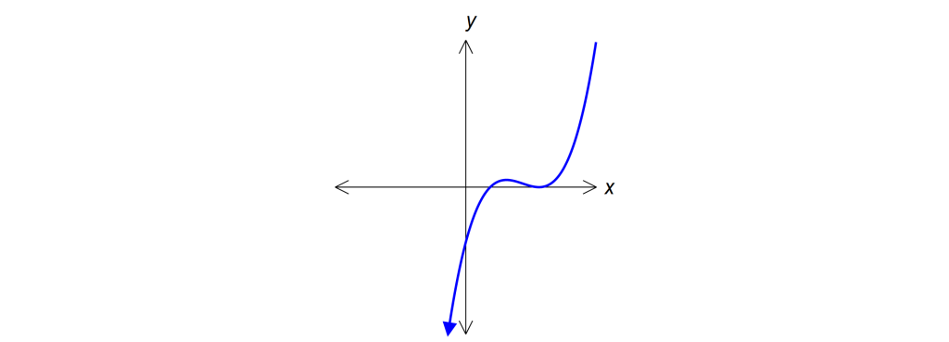  b  a | - Roots at x = a and x = b  - Minimum turning point at x = a  - Gradient is positive at x = b | 1  2  1
(b) | Example of possible function  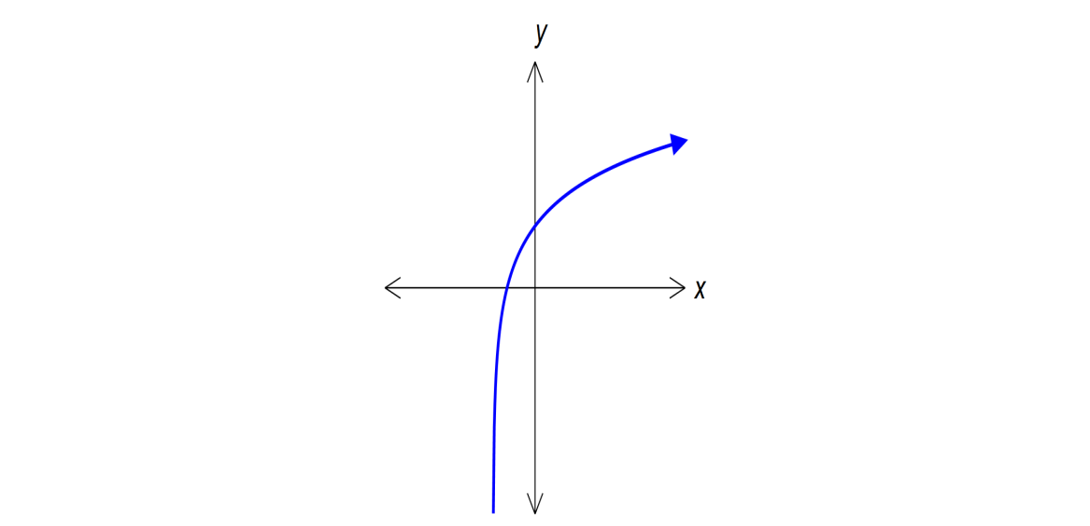 | - Shows a function that is always increasing  (ie. positive gradient)  - Function is concave down | 1  1

Question 4
 | Solution | Mathematical behaviours | Marks
(a) | (i) 2.66667 (5dp)  (ii) 2.72727 (5dp)  (iii) 2.71698 (5dp) | - Correct calculations | 1  1  1
(b) | e | - Recognises values are approaching e | 1

